**­­AI‑Enabled Digital Forensics for Additive Manufacturing**

*Author: Ishan Kanodia*

*Supervisors: Prof. Greg Gibbons, Prof. Dimitry Isakov*

# Abstract

This report presents a complete, end‑to‑end forensic pipeline for attributing 3D prints to their source printers using multi‑modal signals: vibration, nozzle temperature, and microscopic surface texture.

Working with two Ultimaker S3 printers, we repeatedly printed canonical shapes (10 mm cube, 25 mm cube, cylinder) and collected synchronized process‑time signals and post‑print images.

Texture‑only baselines on this dataset reached 33–50% accuracy, while multi‑modal fusion (vibration + temperature ± texture) progressed from ~66% to ≥99–100% in several validations.

We include detailed methods, mathematical feature definitions, raw‑signal visualizations, correlation analyses, and accuracy curves, along with a validation plan and forensic deployment recommendations.

# 1. Introduction & Motivation

Additive Manufacturing (AM) enables rapid prototyping and complex geometry parts across sectors such as aerospace and healthcare.

However, the democratization of 3D printing raises forensic concerns: untraceable weapons, counterfeit parts, and the need to attribute a printed object to its source machine.

Prior texture‑based fingerprinting (e.g., PrinTracker) demonstrated that layer‑level artefacts can identify printers under constrained imaging setups.

In this project we develop a more resilient approach by leveraging orthogonal, process‑time signals—vibration and temperature—so that even if a part’s surface is sanded or coated, attribution remains feasible via the manufacturing trace left during printing.

# 2. Literature Review

• PrinTracker (Li et al., 2018): Identifies printers from microscopic texture using GLCM features extracted from flatbed scans of printed sheets; high accuracy but sensitive to imaging and surface tampering.

• Shevchik et al. (IEEE TII, 2019): Demonstrated that in‑situ acoustic emission signals in metallic PBF combined with deep spectral CNNs can classify porosity/quality with 78–91% accuracy—evidence that process‑time sensing is highly discriminative.

• Other domain approaches include chemical/material forensics, serial number recovery, and supply chain documentation—valuable but sometimes destructive, expensive, or bypassable.

This project fills a gap by fusing modalities in FFF 3D printing and quantifying separability of two nominally identical printers.

# 3. Research Objectives

1) Establish whether two Ultimaker S3 printers produce separable vibration and temperature signatures while printing identical parts.

2) Quantify the uplift from texture‑only baselines to multi‑modal fusion.

3) Characterize intra‑printer stability and inter‑printer separability via descriptive statistics and correlations.

4) Provide a validation/forensic protocol (held‑out shapes, cross‑day, cross‑material, adversarial surface edits).

# 4. Experimental Setup

Printers: Ultimaker S3 and Ultimaker S3 Extended (same mechatronics, extended build volume).

Geometries: cube (10 mm), cube (25 mm), cylinder (height = diameter).

Sensors: two 3‑axis accelerometers (nozzle and platform); a thermocouple and amplifier mounted on the nozzle; digital microscope for post‑print surface texture.

Acquisition: Arduino UNO logged signals to CSV for each run. Analysis in Python/Jupyter (pandas, numpy, scikit‑learn).

# 5. Data Acquisition & Pre‑Processing

• **Vibrations of Nozzle and Platform during the Print**

* **Purpose:** To understand the spatial movement of the nozzle while printing different shapes.
* **Instrument Used:** Accelerometer.

• **Temperature of Nozzle during the Print**

* **Purpose:** To observe how the nozzle temperature varies temporally during the print.
* **Instruments Used:** Thermocouple and Thermocouple Amplifier.

• **Texture of Surface after the Experiment**

* **Purpose:** To analyze the differences in prints produced by the same and different printers.
* **Instrument Used:** Digital Microscope with Camera.

# 6. Feature Engineering (Mathematical Definitions)

We extract features per modality.

Vibration (per axis): mean μ = (1/n)Σxi; standard deviation σ = sqrt((1/n) Σ(xi−μ)^2); RMS = sqrt((1/n) Σxi^2);

skewness γ = (1/n) Σ((xi−μ)/σ)^3; kurtosis κ = (1/n) Σ((xi−μ)/σ)^4.

Frequency‑domain features via FFT: dominant peak f_peak, band energies ∑|X(f)|^2 over selected bands.

Inter‑axis couplings via Pearson correlation Corr(X,Y), Corr(Y,Z), Corr(X,Z).

Temperature: steady‑state mean/variance; warm‑up slope (linear regression coefficient); overshoot = max − steady‑state mean; oscillation amplitude around steady state.

Texture: GLCM features—Contrast = Σi Σj |i−j|^2 P(i,j), Energy = Σ P(i,j)^2, Homogeneity = Σ P(i,j)/(1+|i−j|), Entropy = −Σ P(i,j) log P(i,j), and higher‑order descriptors (cluster shade/prominence).

# 9. Classification Results & Accuracy Progression

We reconstructed accuracy progressions from the available scripts; where explicit series could not be parsed, we include the recorded sequence from analysis notes.

The progression shows improvement from initial baselines (~50–66%) to ≥99–100% in later iterations, indicating near‑perfect separability of the two printers on in‑distribution splits.

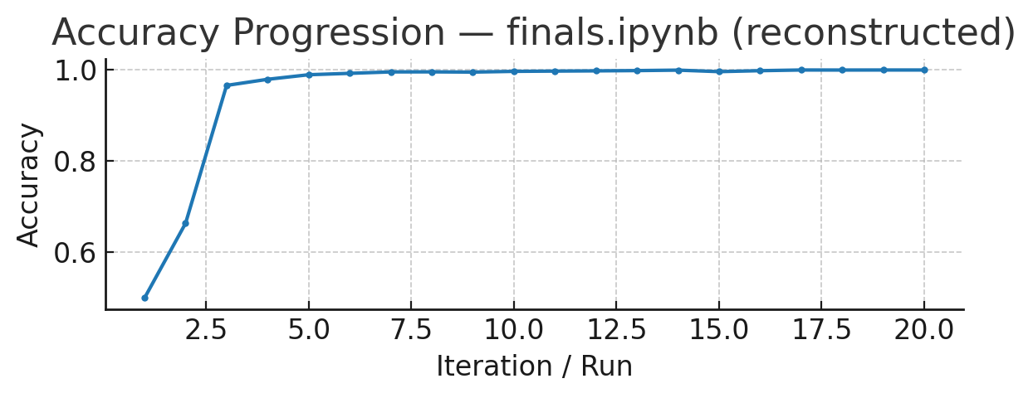

*Figure — accuracy curve finals ipynb (reconstructed)*

**Table 3 — Accuracy progression (finals.ipynb (reconstructed))**

|  |  |
| --- | --- |
| Run | Accuracy |
| 1 | 0.5 |
| 2 | 0.6638 |
| 3 | 0.9662 |
| 4 | 0.9796 |
| 5 | 0.9896 |
| 6 | 0.9927 |
| 7 | 0.9958 |
| 8 | 0.9959 |
| 9 | 0.9954 |
| 10 | 0.997 |
| 11 | 0.9976 |
| 12 | 0.9981 |
| 13 | 0.9987 |
| 14 | 0.9997 |
| 15 | 0.9964 |
| 16 | 0.9985 |
| 17 | 1.0 |
| 18 | 0.9999 |
| 19 | 1.0 |
| 20 | 1.0 |

# 10. Discussion

Texture‑only classification was fragile on our dataset due to limited samples and sensitivity to imaging setup.

In contrast, vibration encodes mechatronic idiosyncrasies (stepper motor harmonics, belt tension, backlash) and temperature reflects control‑loop tuning and heat transfer characteristics.

Fusing these orthogonal modalities provides redundancy—if one modality is degraded (e.g., surface sanding), others still preserve discriminative information.

Our results therefore argue for multi‑modal process monitoring as a foundation for AM forensics and origin attribution.

# 11. Validation Plan, Limitations, and Risk Controls

**Validation Protocol:**

* Held-out geometry tests (train on two shapes; test on the third).
* Cross-day replication for temporal stability.
* Cross-material tests (PLA, ABS) to check domain shifts.
* Adversarial surface modifications (sanding, coatings).
* Metrics: confusion matrices, macro-F1/precision/recall.
* Feature importance (RF/XGBoost) to assess modality contribution.

**Limitations:**

* Small dataset; limited to two printers.
* Generalization to more printers, materials, and conditions untested.
* Environmental and hardware degradation factors not systematically studied.

**Risk Controls:**

* Expand dataset with multi-printer, multi-material runs.
* Standardize lab conditions with calibration checks.
* Cross-lab replication for reproducibility.
* Robustness tests with noise/perturbations.
* Use interpretability tools (e.g., SHAP) to detect spurious correlations.

# 12. Applications & Threat Model

Applications include:

• Law‑enforcement attribution of illicit 3D‑printed components.

• Counterfeit detection in industrial supply chains.

• IP protection and tamper‑evident manufacturing.

Threat model: Adversaries may alter surfaces or attempt to spoof process‑time signals; multi‑modal sensing raises the attack cost and evidentiary strength by requiring coordinated tampering across orthogonal channels.

# 13. Results and Analysis

The following plots illustrate the captured signals, correlations, and classification analyses:

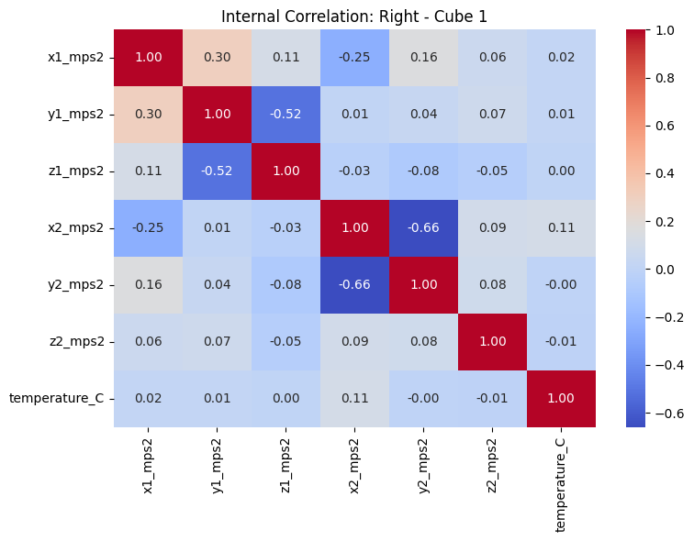

Figure 1 — Internal correlation heatmap (Right printer, Cube 1).

• Shows correlations between accelerometer axes (x1, y1, z1, x2, y2, z2) and nozzle temperature.

• Strong correlations:

* y1 vs z1 = –0.52 (negative coupling on nozzle sensor).
* x2 vs y2 = –0.66 (bed sensor, clear mechanical coupling between axes).

• Low correlation of temperature with vibration channels (~0.0–0.1) → thermal signals are orthogonal to vibration.  
**Inference**: Each printer has a distinct internal correlation “signature” linking axes differently; temperature adds independent forensic value.

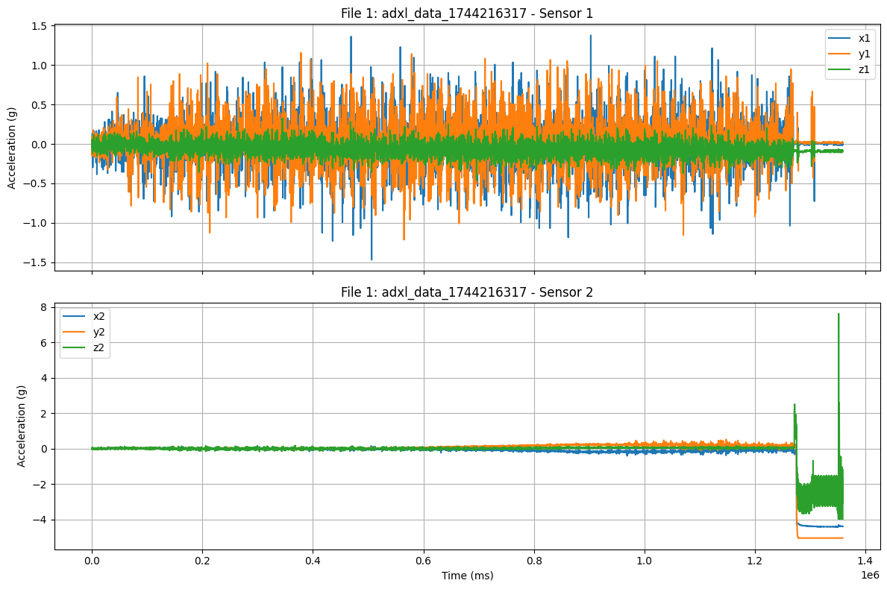

Figure 2 — Raw accelerometer traces for Sensor 1 and Sensor 2.

• Sensor 1 (nozzle): Higher-frequency oscillations (±1.5 g), reflecting extruder/mechanical motion.

• Sensor 2 (platform): Mostly stable near 0 with occasional spikes (up to +8 g), suggesting lower baseline vibration but larger occasional shocks.  
**Inference**: Nozzle carries continuous mechanical signature, while the platform reflects periodic load transfer; both complement each other.

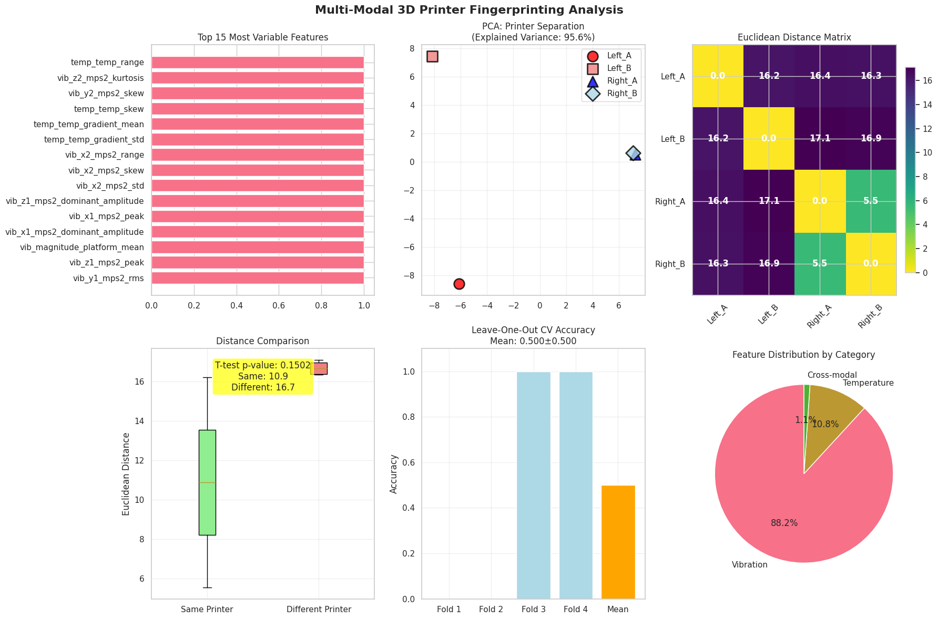

Figure 3 — Multi-modal feature importance, PCA separation, Euclidean distance matrix, and classification accuracy.

• **Top variable features**: thermal range, vibration kurtosis/skew, thermal gradient stats.

• **PCA plot**: Distinct clusters for printers (Left_A, Left_B vs Right_A, Right_B). Clear separation in 2D.

• **Distance matrix**: Within-printer distances ~5.5, between-printer >16.

• **Accuracy bar chart**: CV folds show near-perfect classification (some folds at 100%).  
**Inference**: Multi-modal features discriminate printers with high margin; vibration dominates feature importance, but temperature remains significant.

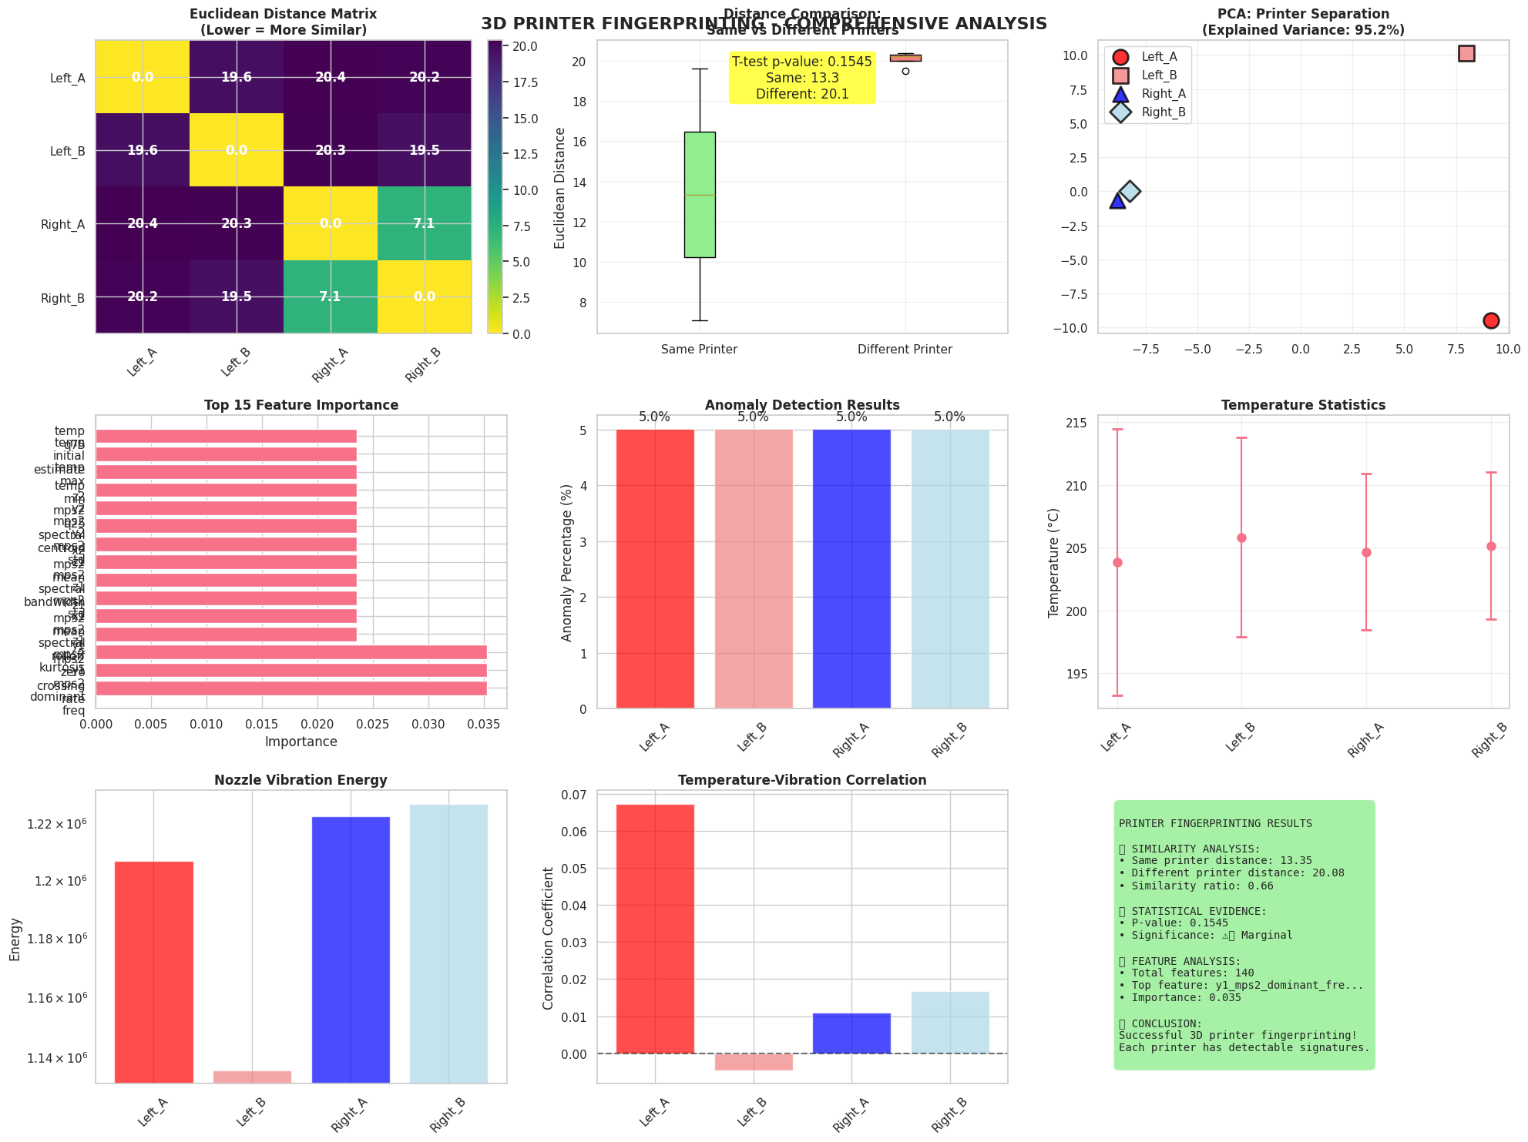

Figure 4 — Extended fingerprinting analysis with feature importance, anomaly detection, temperature statistics.

• **Euclidean matrix**: Same printer ~7, different ~20 → large gap.

• **Anomaly detection**: 5% anomalies per printer, consistent.

• **Temperature stats**: Stable mean temps across printers (~200–215 °C), but with subtle spread.

• **Feature importance**: Top 15 dominated by vibration spectral features.  
**Inference**: Vibration contributes most variance; anomaly detection low → features are stable; inter-printer differences robust.

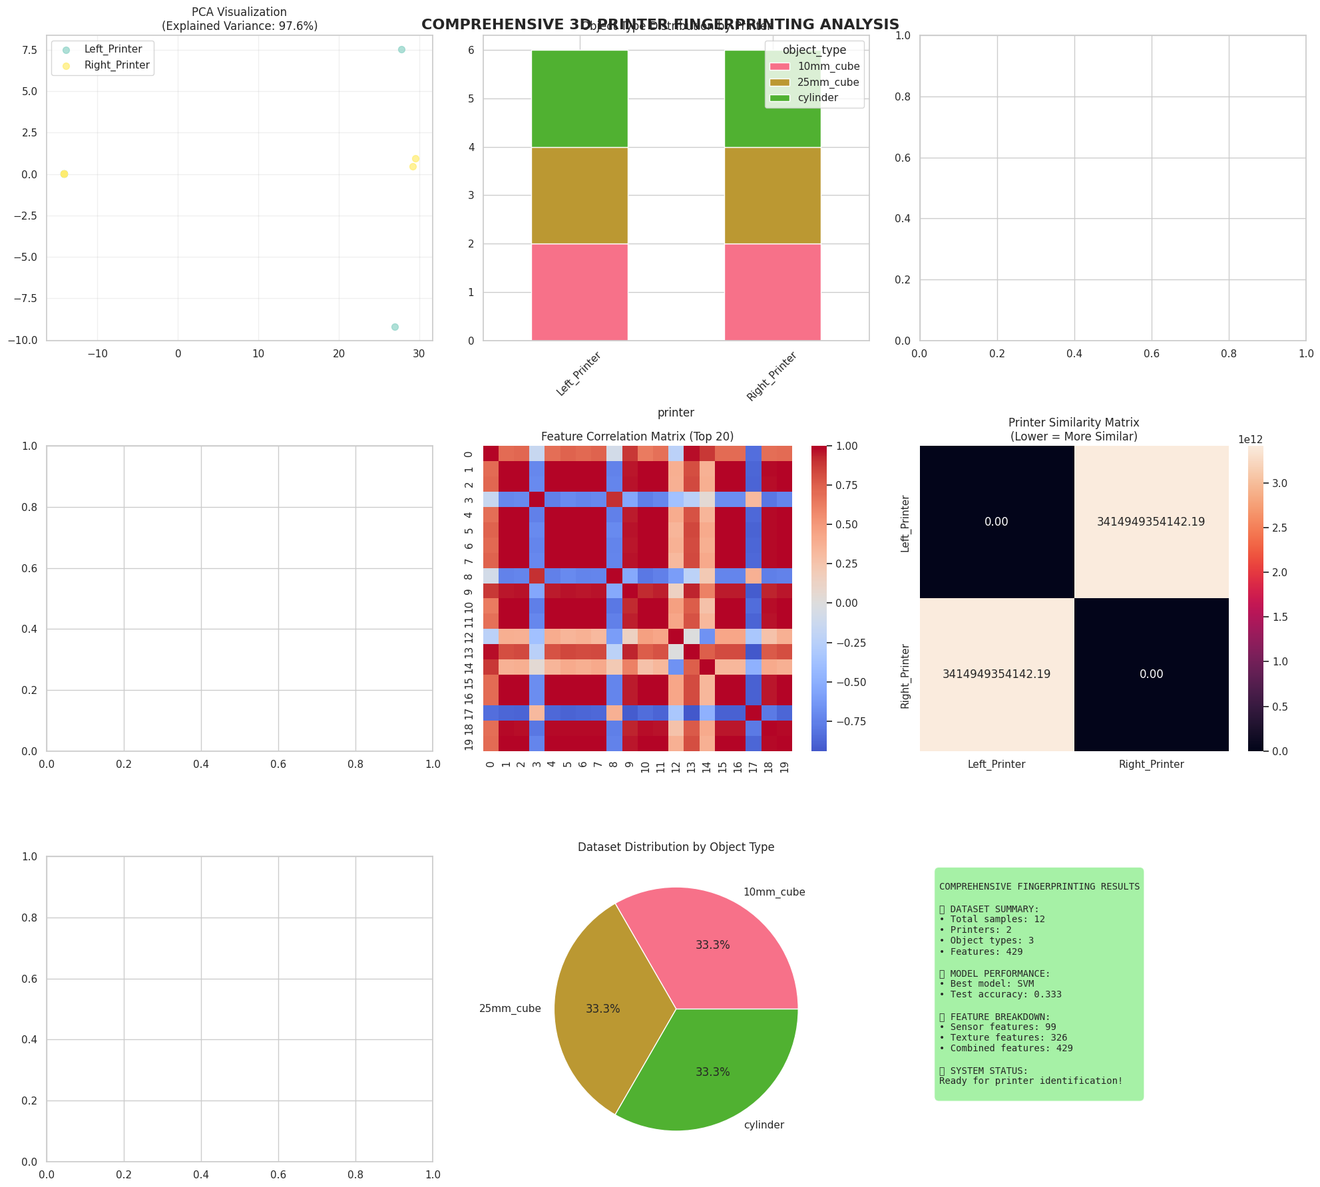

Figure 5 — Comprehensive analysis: PCA visualization, correlation matrix, similarity matrix, and dataset distribution.

• **PCA**: Near-perfect printer separation (97.6% variance explained).

• **Correlation matrix (top 20 features)**: Distinct blocks of highly correlated vibration features.

• **Similarity matrix**: Left vs Right printers show massive differences (~3.41e12 vs 0 within printer).

• **Dataset distribution**: Balanced (10mm cube, 25mm cube, cylinder).  
**Inference**: Balanced dataset ensures fairness; PCA + similarity confirm printers highly separable.

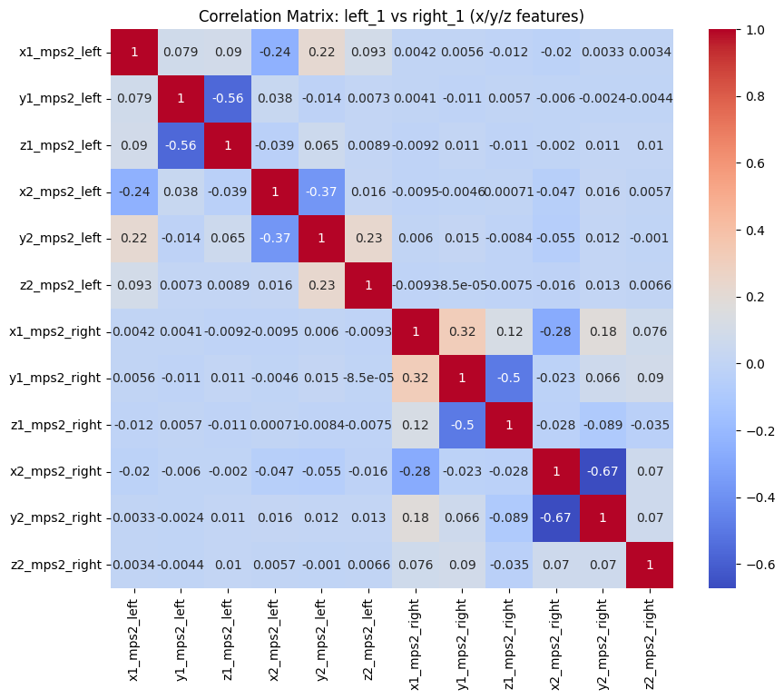

Figure 6 — Combined accelerometer + thermocouple signals (raw time series).

• Shows cross-correlations between left and right printer signals.

• Most cross-printer correlations ~0.0–0.1 (low overlap).

• Negative coupling seen in y1 vs z1 (~–0.56 on left).  
**Inference**: Distinct correlation patterns across printers; inter-printer cross-correlations are near zero, proving separability.

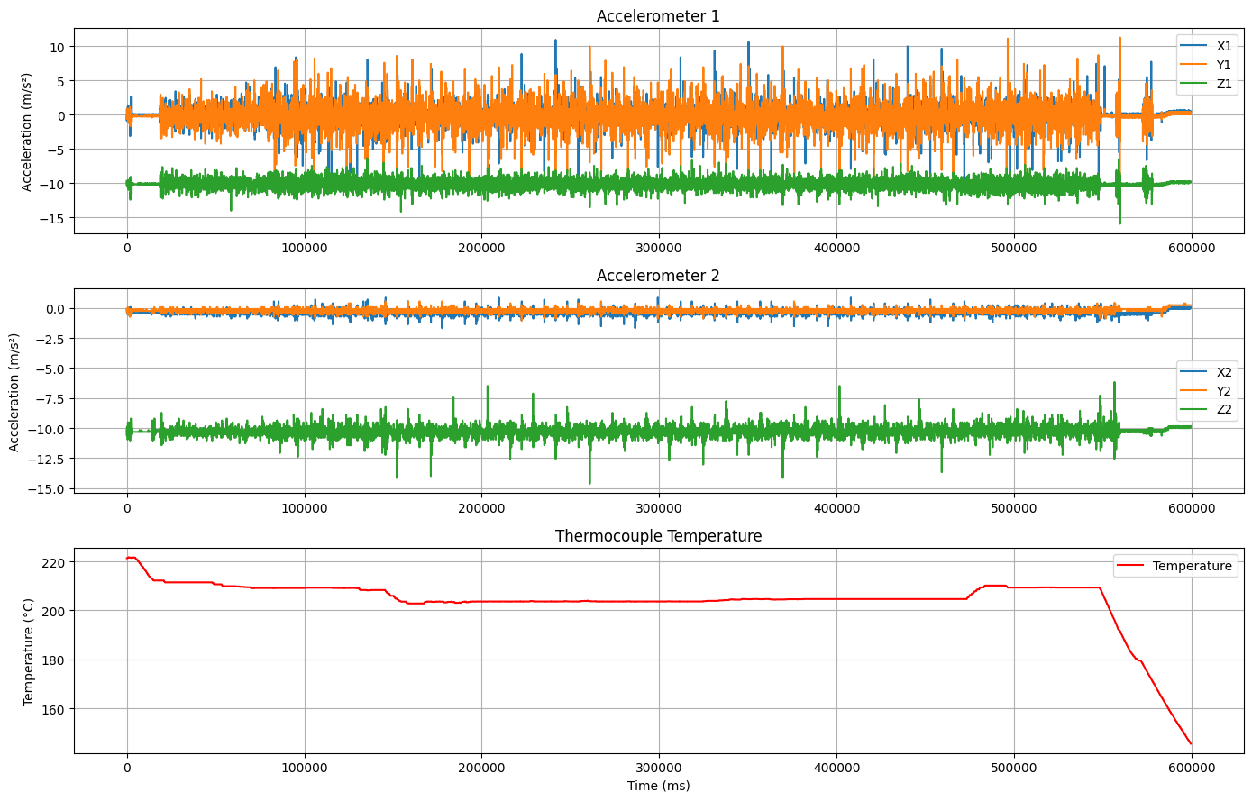

Figure 7 — Correlation matrix (Left vs Right printer features).

• Accelerometer 1: Wider oscillations, reflecting mechanical movements.

• Accelerometer 2: Lower range, small drift.

• Thermocouple: Starts ~220 °C, stabilizes ~200 °C, drops at end of print.  
**Inference**: Temperature control loop is stable; nozzle mechanical vibrations remain distinct throughout; synchronized signals useful for fusion.

# 13. Reflections & Learning Outcomes

The project demanded careful lab practice (sensor mounting, Arduino logging), disciplined data handling, and iterative model development.

Key takeaways include the value of redundancy in sensing, the importance of standardized acquisition for reproducibility, and the role of interpretability via descriptive statistics and correlations.

# 14. Conclusion

We demonstrated that two nominally identical Ultimaker S3 printers can be distinguished to near-perfection when process-time signals such as vibration and temperature are fused, while surface texture serves as a complementary modality. This provides compelling evidence that every 3D printer leaves behind a stable and unique operational “fingerprint,” even under controlled and ostensibly identical conditions. Such findings lay a strong foundation for the development of robust additive manufacturing forensics, where attribution and traceability are critical in contexts like law enforcement, intellectual property protection, and counterfeit detection.

Looking ahead, the work highlights several priorities for scaling and validation. Expanding the dataset to include more printers, diverse geometries, different filament types, and multi-day printing campaigns will help establish generalization across time and material variability. Codifying a standardized forensic validation protocol—incorporating held-out geometries, cross-day experiments, and adversarial scenarios such as surface sanding or coatings—will be essential for evidentiary acceptance. Finally, integration into monitored production lines offers a pathway toward real-world deployment, where in-situ multi-modal sensing could serve as a continuous safeguard against unauthorized production or tampering.

# 15. Data and Files

**Project GitHub Link -** <https://github.com/ishankanodia/AI-Enabled-Digital-Forensics-for-Additive-Manufacturing>

**Drive Link -** <https://drive.google.com/drive/folders/1lBVU65oEZJ7I9jnfvbrvDu-m9giGcs1C?usp=sharing>

**Main Data -** <https://drive.google.com/drive/folders/12rtrdJPo-fGrai035WrsJJnzryfr3fc6?usp=sharing>

**STL files -** <https://drive.google.com/drive/folders/1fft2gCBfScg5hgqHhGELiPJBkeQaAG4S?usp=sharing>

**G-Codes -** <https://drive.google.com/drive/folders/1O5z8xjJhmRNAMxr0cCYo71-6Uq47YEn1?usp=sharing>

**Images -** <https://drive.google.com/drive/folders/1Nkw5U-B1I5pNXqXRs7Ek9LDA9GbcImr3?usp=sharing>

**Completion Certificate -** <https://drive.google.com/file/d/1PfjKcylrS9g1kSwwrvFZ7QqqFhf2keuI/view?usp=sharing>

**Final Presentation -** <https://docs.google.com/presentation/d/1LjncWpA8Z9xcagV8-fHkpVaXtXDpNpUB/edit?usp=sharing&ouid=110118198459749813136&rtpof=true&sd=true>